# Homework for 14 Beetroot lesson “Web basics”

## Beet Seed

### Протестуй сайт <https://avtozvuk.ua/ua/>, знайшовши 3 баги

1. **Avtozvuk-1**

**Summary:** Pressing the “Feedback” button doesn’t work in the subblock of hover-element with the phone number.

**Priority:** 3 / **Severity:** 2

**Preconditions:** Website <https://avtozvuk.ua/ua/> is opened in browser.

**Bug description:**  
 ***Location:*** *The phone number with dropdown menu near it, in the products catalog and search line with gray background color above the header menu.*

Clicking on the arrow near the phone number, triggers a dropdown menu to show up. In the menu, the “Feedback” button is available, but if clicking on it nothing happens.

**STR:**

1. Navigate to the homepage of website;
2. Click on arrow near the phone number;
3. Click on “Feedback” button;
4. Notice nothing has happened.

**Expected result:** After pressing on the “Feedback” button, the dialog window must appear with fields to specify the phone that will be used to reach out.

**Actual result:** After pressing on the “Feedback” button nothing happens.

**Attachments:**

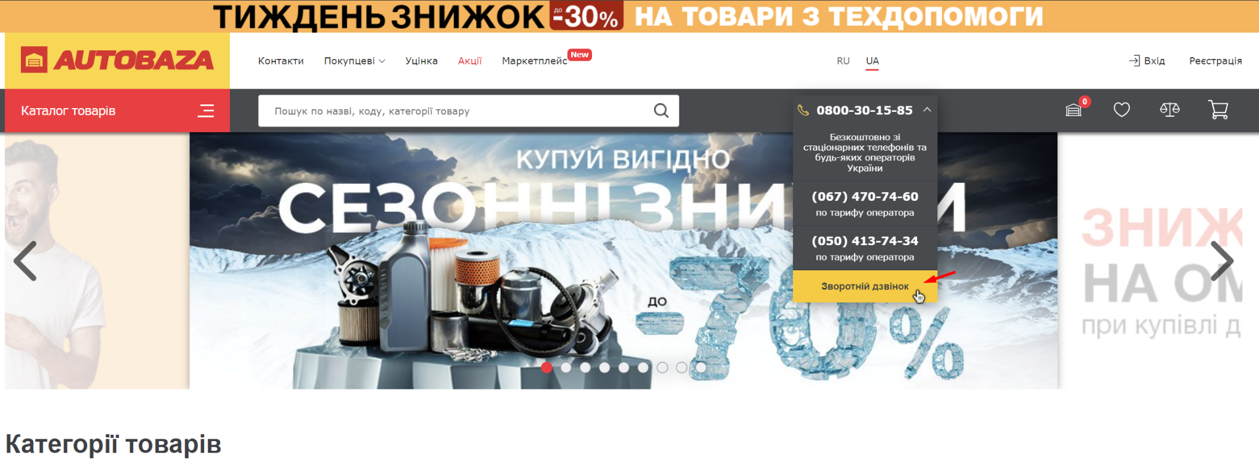

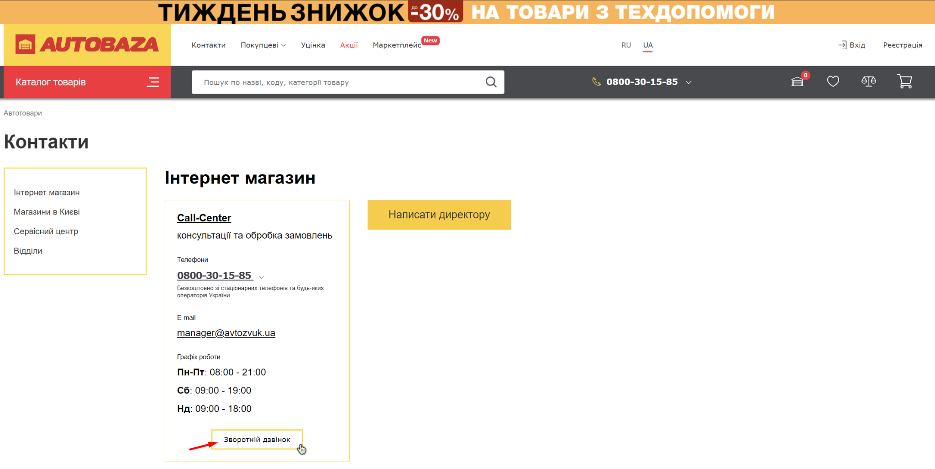

1. **Avtozvuk-2**

**Summary:** Mistranslation of text in the block “List of categories with bulky goods”.

**Priority:** 5 / **Severity:** 4

**Preconditions:** Website <https://avtozvuk.ua/ua/> is opened in browser.

**Bug description:**  
 ***Location:*** *Menu section “For the buyers -> Delivery”, prefooter of the page.*

Text “Павільйоны” is mistranslated in the footer of website.

**STR:**

1. Choose the Ukrainian translation of website;
2. Navigate to the menu section “For the buyers -> Delivery”;
3. Scroll down to the prefooter of page;
4. Notice the text “Павільйоны” is mistranslated.

**Expected result:** The text must be translated as “Павільйони”.

**Actual result:** The text is translated as “Павільйоны”.

**Attahcments:**

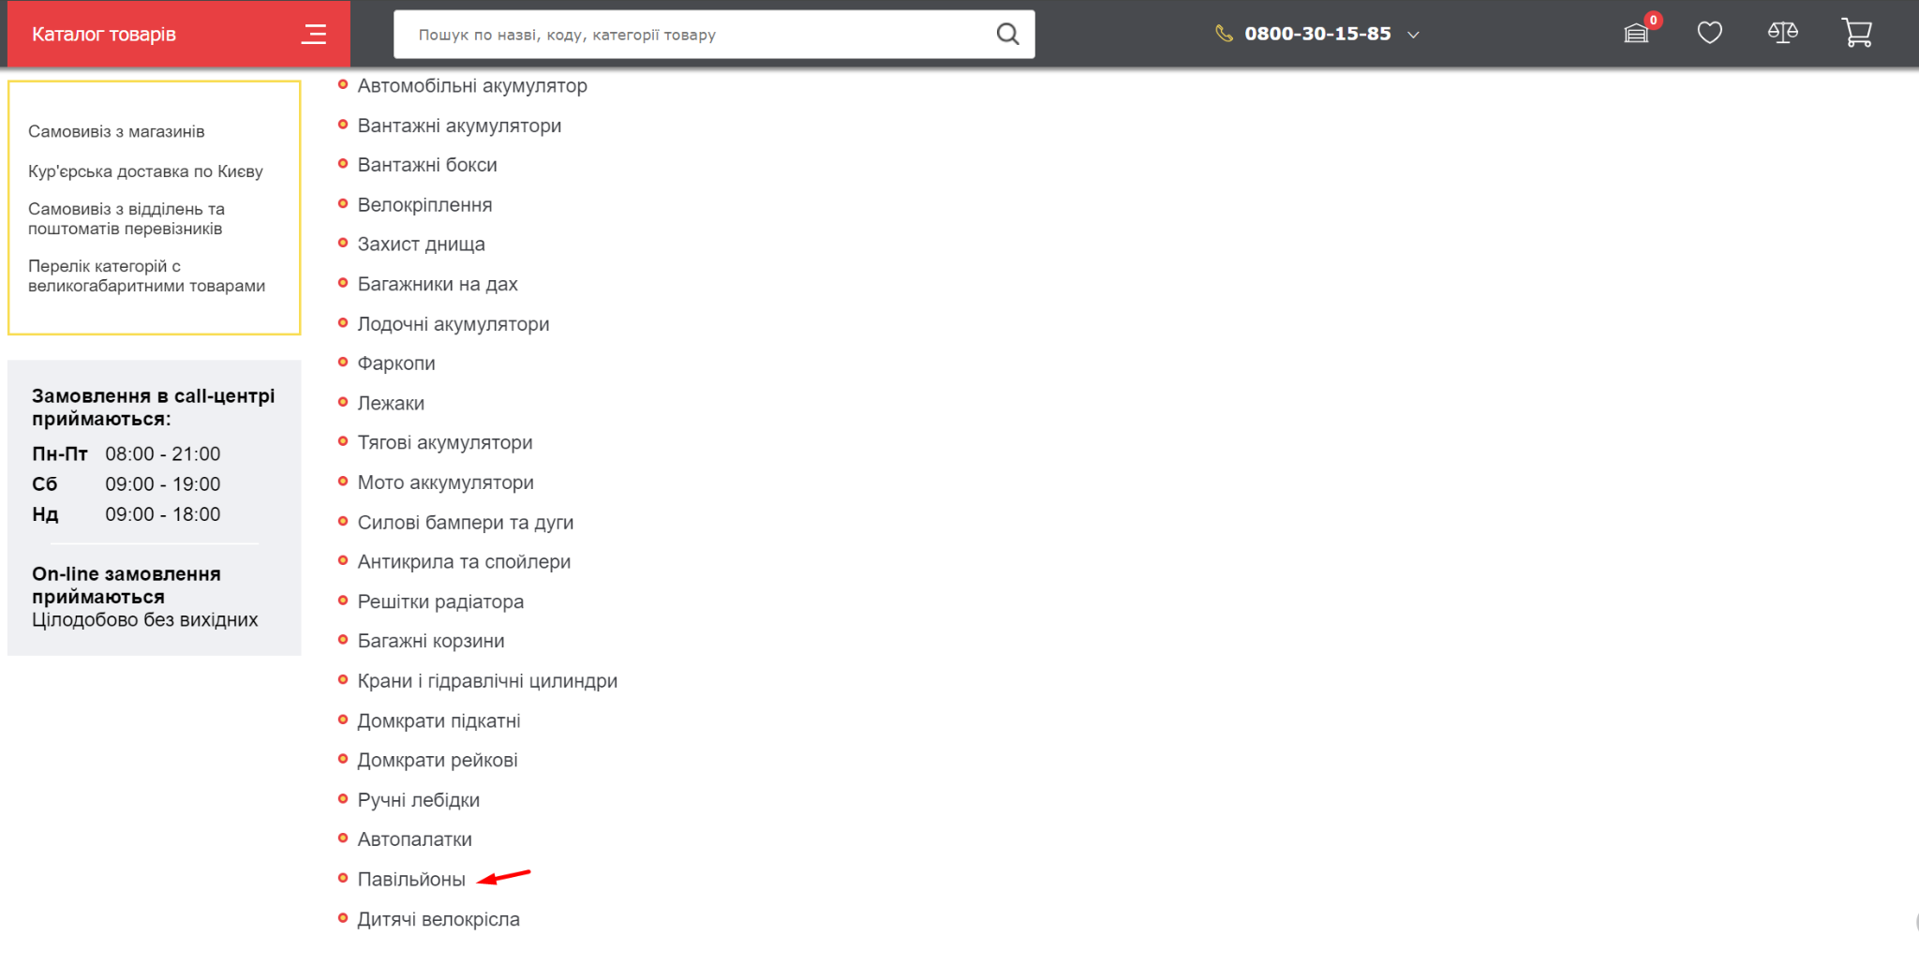

1. **Avtozvuk-3**

**Summary:** No icons near the text in the menu of the desktop website version.

**Priority:** 4 / **Severity:** 5

**Preconditions:** Website <https://avtozvuk.ua/ua/> is opened in browser.

**Bug description:**  
 ***Location:*** *Main page of website, text of sections in the menu.*

In the mobile version of the website, the icons next to the sections text in the menu are available, which makes site navigation more inuitive for the user. But for the desktop website vesion, the icons are absent next to the text in the menu.

**STR:**

1. Open the mobile website version in any way;
2. Navigate to the homepage of the website;
3. Open the menu, notice the icons next to the text for each menu sections;
4. Open the mobile website version;
5. In the menu line, notice the icons are absent next to the text of menu sections.

**Expected result:** The icons are available next to the text in the menu for both website versions.

**Actual result:** In the menu of the desktop website version the icons are absent next to the text of menu sections.

**Attachments:**

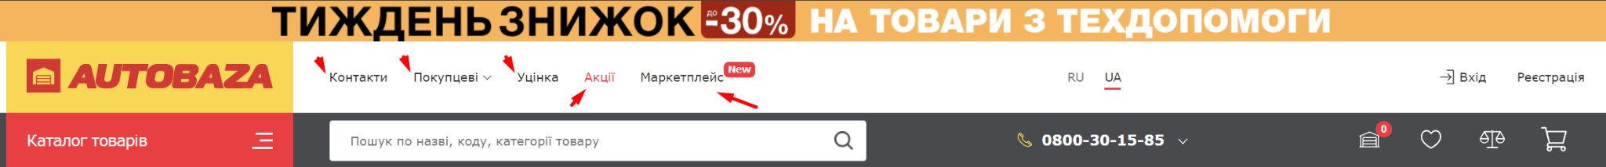

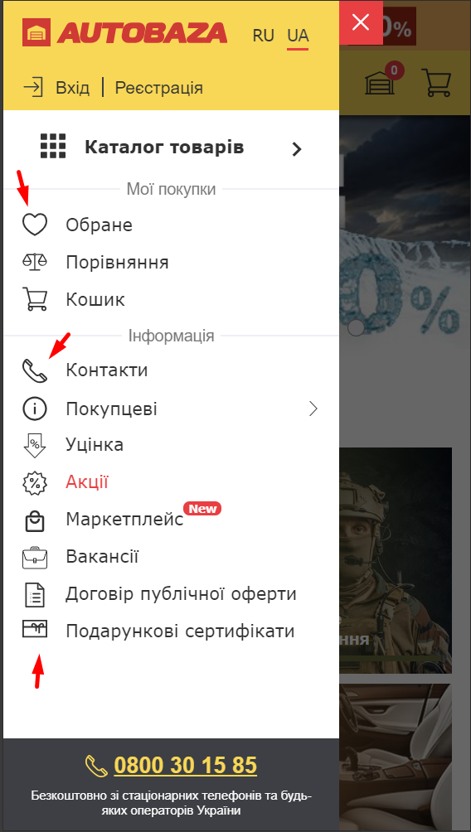

## Створи єдиний HTML-документ з підключенням в ньому стилів трьома різними способами

The HTML document is available at [github](https://github.com/lastochka364/beetrootqa/tree/main/Basics%20of%20web.%20HTML.%20CSS.%20Character%20coding). This [link](https://html-preview.github.io/?url=https://github.com/lastochka364/beetrootqa/blob/main/Basics%20of%20web.%20HTML.%20CSS.%20Character%20coding/index.html) also allows you to directly view the file itself, without having to download it.

## Перевір відображення створеного документа в різних браузерах

Google Chrome:

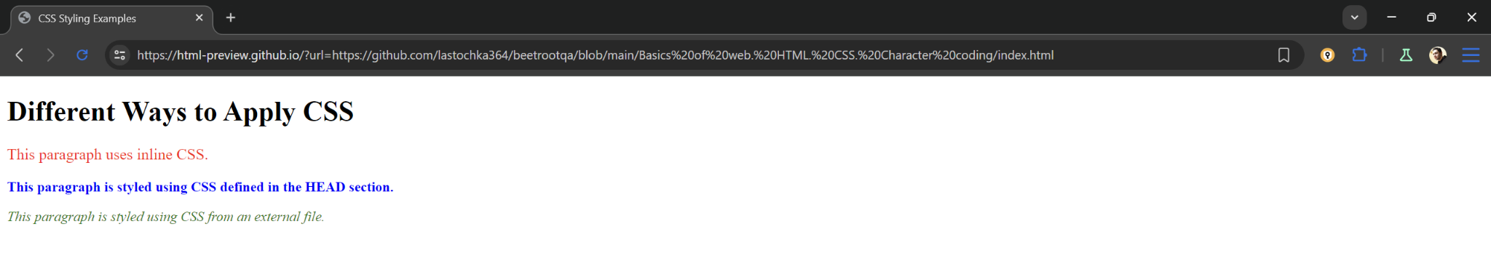

Firefox:

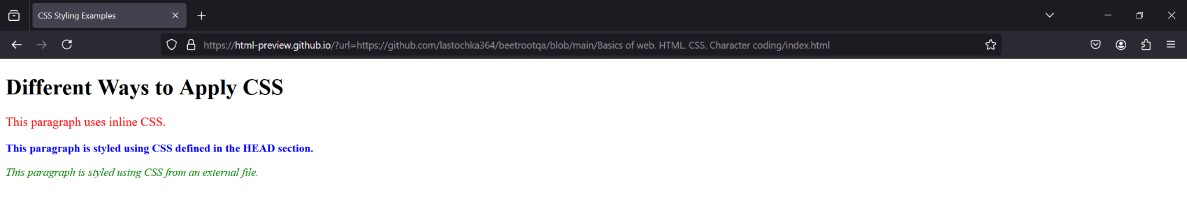

Edge:

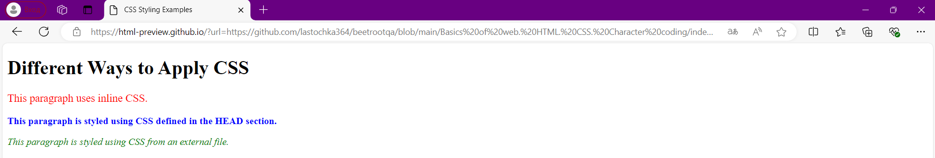

## Коротко опиши різницю у відображенні елементів

All I have noticed is the font difference. This happens because of the browser settings - it sets the font the user choosed on all pages and for all elements, only if the website has not overwritten the value in the variable with the font setting.

## За допомогою Developer Tools визнач кодування символів, використаних на вебсторінках

* [Beetroot Academy](https://beetroot.academy/): utf-8

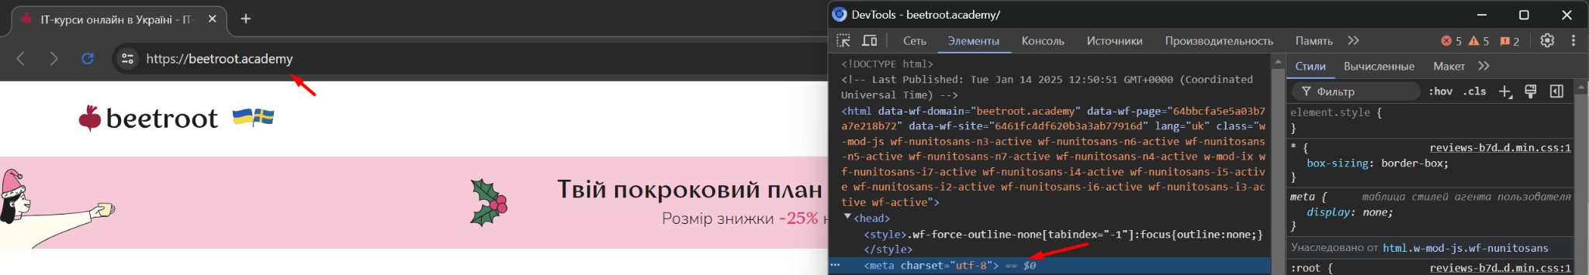

* [Microseniors](https://microseniors76.com/): iso-8859-1

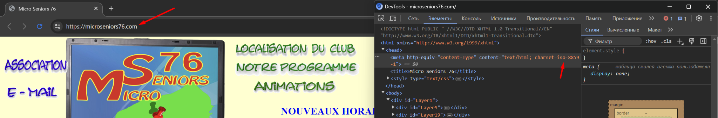

* [Tennis-Warehouse](https://www.tennis-warehouse.com/): ascii

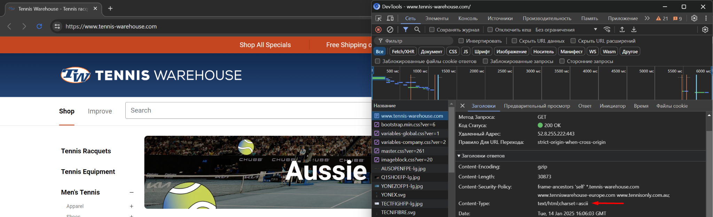

* [Fidelity](https://www.fidelity.com/): utf-8

